The rise in EV Vehicles and its underlying factors
Mohammad Ahnaf Masud

Schiller International University of Madrid

Professor Dhaval Gadariya

January 11, 2026

Table of Contents
Table of Contents 2
Abstract 4
Introduction 5
Methodology 6
Data Source 6
Data Cleaning 6
Regression Models 6
Results 7
Factors Driving EV Growth 7
Factor 1: Market Growth - Global EV Stock 7
Factor 2: Consumer Demand - Annual EV Sales 7
Factor 3: Government Policies - Country Leadership 7
Factor 4: Policy Effectiveness - EV Sales Share 7
Factor 5: Infrastructure - Charging Points Growth 9
Factor 6: Environmental Impact - Oil Displacement 9
Factor 7: Technology Shift - BEV vs PHEV 9
Factor 8: Growth Momentum - Year-over-Year Growth Rate 9
Factor 9: Correlation Between EV Indicators 10
Factor 10: Policy Impact Over Time 10
Regression Analysis Results 11
Train/Test Split 11
Simple Linear Regression 11
Multiple Linear Regression 11
Polynomial Regression (Non-Linear) 11
Model Comparison 12
Actual vs Predicted (Test Set Validation) 12
Residual Analysis 12
Future Predictions (2025-2030) 13
EV Stock Forecast 13
EV Sales Forecast 13
Ethical Considerations 14
Conclusion 14
References 16

Abstract
Electric Vehicles have experienced remarkable worldwide growth over the past decade. This report provides a comprehensive data analytics study of global EV adoption using historical data obtained from the International Energy Agency (IEA). The dataset includes EV stock, EV sales, charging infrastructure development, EV sales share, oil displacement, and powertrain distributions across a broad range of countries and regions. A structured workflow was applied, involving data importation, data cleaning, exploratory data analysis, visualization, regression modeling, and future predictions.
The results reveal a clear acceleration in global EV adoption after 2018, with China, Europe, and the United States emerging as the most significant contributors to the global rise. Key factors driving EV adoption include government policies (subsidies, tax exemptions, mandates), falling battery costs, expanding charging infrastructure, and environmental benefits such as oil displacement. Battery Electric Vehicles (BEVs) show a more pronounced and consistent growth trajectory than Plug-in Hybrid Electric Vehicles (PHEVs), suggesting a worldwide shift toward fully electric mobility.
Three regression models were applied: Simple Linear Regression, Multiple Linear Regression (using Year and Charging Infrastructure as predictors), and Polynomial Regression (Non-Linear). The Polynomial Regression model (Degree 3) achieved the highest R² score, demonstrating that EV growth follows an exponential pattern rather than linear growth. Based on this model, global EV stock is forecasted to exceed 200 million vehicles by 2030, with annual sales projected to surpass 30 million vehicles per year.

Introduction
The global transportation sector is undergoing a major transformation as Electric Vehicles increasingly replace traditional internal combustion engine vehicles. Rising climate concerns, the push toward carbon reduction, improvements in battery technology, and policy interventions by governments have accelerated the shift toward electric mobility. According to the International Energy Agency's Global EV Outlook 2025, electric car sales exceeded 17 million globally in 2024, reaching a sales share of more than 20%.
Understanding the factors driving global EV adoption is essential for forecasting future growth and evaluating the readiness of countries and regions for further EV expansion. This study focuses on analyzing historical EV data from the International Energy Agency to understand: (1) how EV adoption has evolved worldwide over time, (2) what factors are driving the rise of EVs, (3) which government policies have been most effective, and (4) what the future of EV adoption looks like through 2030.
The analysis includes data importation, cleaning, exploratory data analysis, visualizations examining key indicators, regression modeling using Linear, Multiple Linear, and Polynomial approaches, and future predictions based on the best-performing model.

Methodology

Data Source
The dataset used in this analysis was sourced from the IEA Global EV Data Explorer, a publicly available and authoritative source that compiles annual EV statistics for vehicles, powertrain types, charging infrastructure, and regional aggregates. The dataset is available under the Creative Commons BY 4.0 license, meaning it can be used freely with proper attribution. The dataset contains 16,437 rows covering the years 2010-2024 with the following parameters: EV stock, EV sales, EV sales share, EV charging points, oil displacement, electricity demand, and battery demand.

Data Cleaning
Data were imported into Python using the pandas library. The following cleaning steps were applied: (1) Removed projection data, keeping only historical records, (2) Filtered data to years ≤ 2024, (3) Removed duplicate entries, (4) Standardized column names, and (5) Converted value column to numeric format. After cleaning, the dataset contained verified historical observations suitable for analysis and modeling.

Regression Models
Three regression approaches were applied to model and predict EV adoption:
1. Simple Linear Regression: Uses Year as the single predictor variable. Assumes constant growth rate.
2. Multiple Linear Regression: Uses Year and Charging Infrastructure as predictor variables. Tests whether infrastructure investment correlates with EV adoption.
3. Polynomial Regression (Non-Linear): Uses polynomial features (degrees 2, 3, 4) to capture non-linear, exponential growth patterns.
Models were evaluated using R² Score (coefficient of determination), Mean Absolute Error (MAE), and Root Mean Squared Error (RMSE). A train/test split of 80/20 was used, with training data from 2010-2020 and test data from 2021-2024.

Results

Factors Driving EV Growth

Factor 1: Market Growth - Global EV Stock
Global EV stock has increased at a rapid pace, growing from under 1 million vehicles in 2010 to over 45 million in 2024 – a 45x increase. The growth pattern shows clear acceleration after 2018, indicating exponential rather than linear growth. This upward trajectory reflects improvements in battery technology, increased affordability, and widespread policy support for sustainable transportation.
[Figure 1: Global EV Stock Growth 2010-2024]

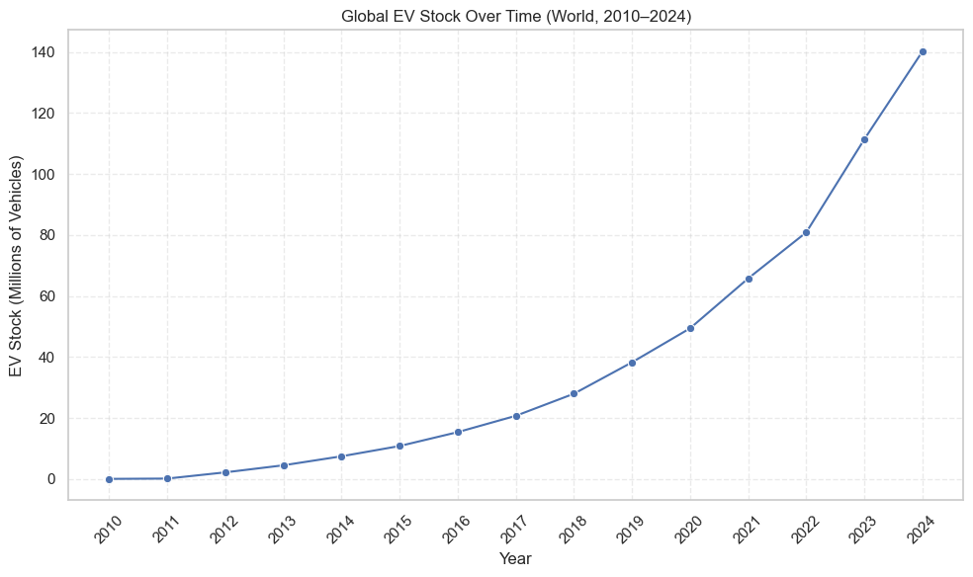

Factor 2: Consumer Demand - Annual EV Sales
Annual EV sales reached 17 million in 2024, meaning 1 in 5 cars sold globally was electric. Sales growth accelerated dramatically after 2020, driven by COVID-19 stimulus packages that favored green vehicles, more affordable EV models entering the market, increased charging infrastructure availability, and stricter emissions regulations in Europe and China.
[Figure 2: Annual EV Sales 2010-2024]

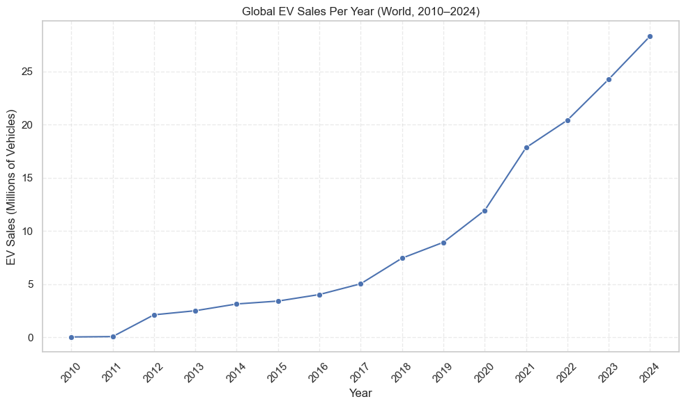

Factor 3: Government Policies - Country Leadership
China dominates with the largest EV stock globally due to their NEV (New Energy Vehicle) mandate requiring manufacturers to produce a minimum percentage of electric vehicles, generous purchase subsidies for consumers, heavy investment in charging infrastructure, and strong domestic EV manufacturers (BYD, NIO, etc.). European countries and USA follow due to CO2 standards and tax incentives like the US $7,500 federal tax credit.
[Figure 3: Top 10 Countries by EV Stock]

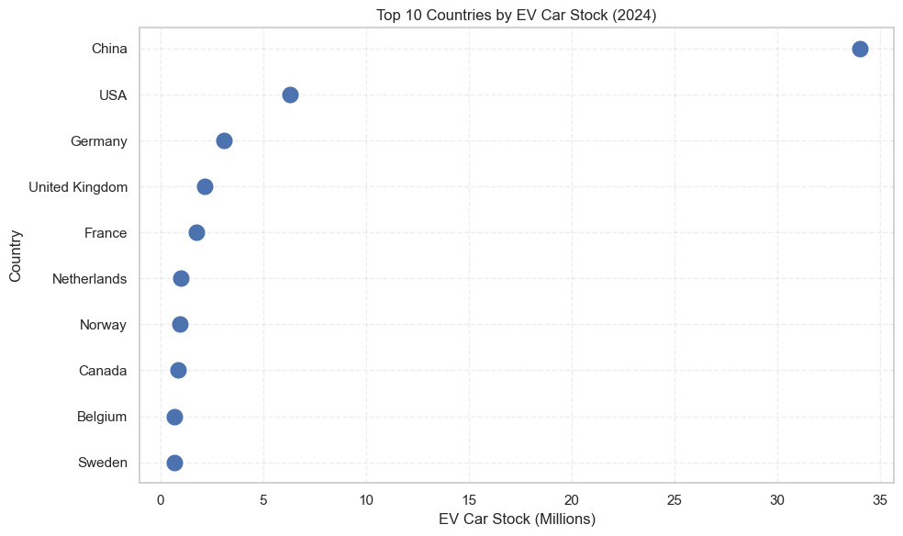

Factor 4: Policy Effectiveness - EV Sales Share
EV Sales Share (percentage of all new car sales that are electric) is the best indicator of policy effectiveness. Norway leads with over 90% EV sales share due to no purchase tax on EVs (saving ~$10,000+), no VAT (25% savings), free municipal parking and toll roads, access to bus lanes, and policies that started in the 1990s. Countries with sales share above 50% have markets dominated by EVs, 20-50% indicates strong growth, and below 20% represents emerging markets.
[Figure 4: EV Sales Share by Country]

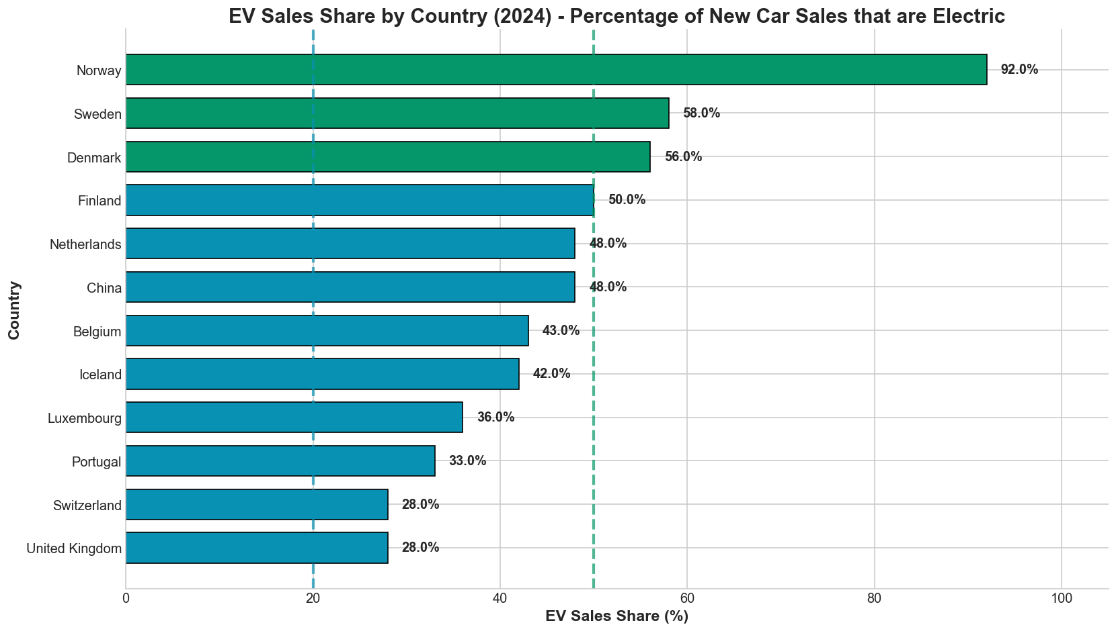

Factor 5: Infrastructure - Charging Points Growth
"Range anxiety" (fear of running out of charge) has been a major barrier to EV adoption. Governments and companies have invested heavily in charging stations to address this concern. Charging infrastructure has grown exponentially alongside EV sales, with over 4 million public charging points installed globally by 2024. This parallel rise demonstrates that the necessary support systems are expanding to accommodate the growing number of electric vehicles.
[Figure 5: Charging Infrastructure Growth]

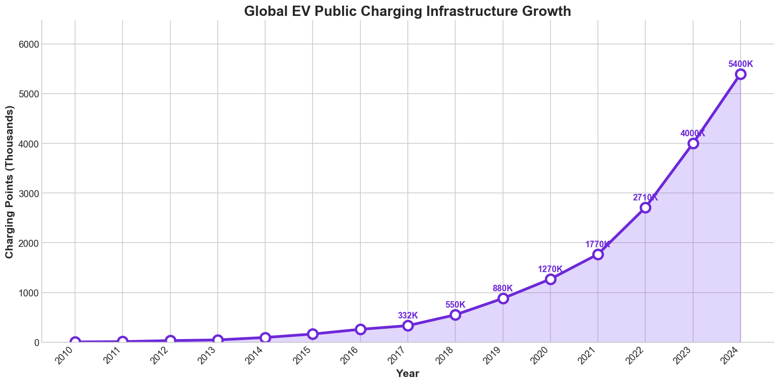

Factor 6: Environmental Impact - Oil Displacement
One of the main motivations for promoting EVs is to reduce oil consumption and CO2 emissions. In 2024, EVs displaced over 1 million barrels of oil per day globally. This reduces CO2 emissions from burning gasoline/diesel, decreases air pollution in cities (no tailpipe emissions), and reduces dependence on oil imports. By 2030, EVs are expected to displace over 5 million barrels per day according to IEA projections.
[Figure 6: Oil Displacement by EVs]

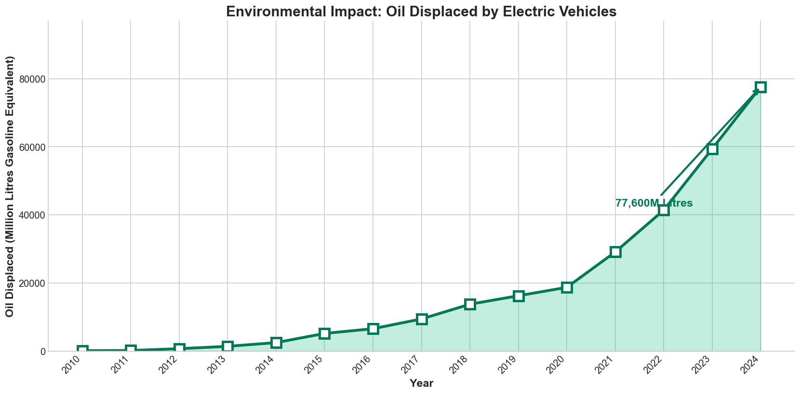

Factor 7: Technology Shift - BEV vs PHEV
Battery Electric Vehicles (BEV, 100% electric) now dominate with approximately 70% market share over Plug-in Hybrid Electric Vehicles (PHEV, has both battery and gasoline engine). Consumer preference has shifted toward BEVs due to longer driving range (400+ km) reducing range anxiety, lower maintenance costs (no oil changes, fewer parts), better environmental credentials (zero tailpipe emissions), and falling battery prices making BEVs more affordable.
[Figure 7: BEV vs PHEV Market Share Over Time]

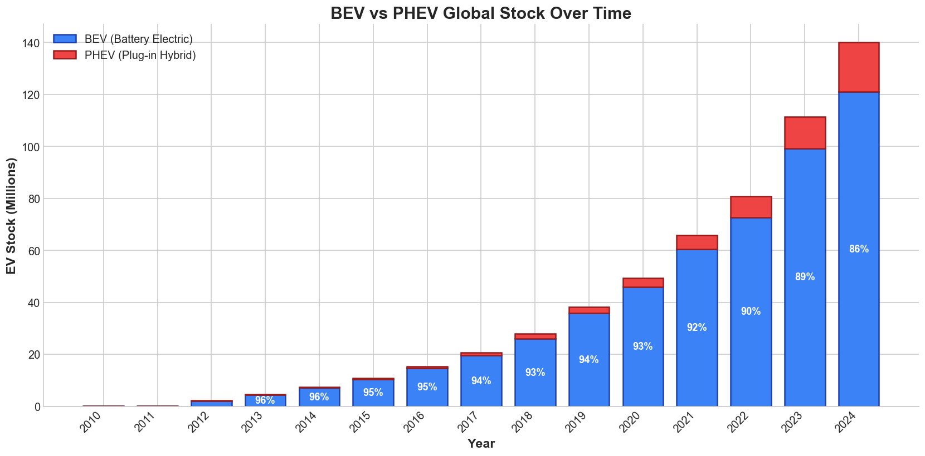

Factor 8: Growth Momentum - Year-over-Year Growth Rate
The EV market has maintained strong year-over-year growth rates of 30-50% annually. Even in "slow" growth years, expansion exceeded 20%. This sustained momentum indicates EVs are not a temporary trend but a permanent market shift. The consistent high growth rates provide confidence for long-term forecasting and infrastructure planning.
[Figure 8: Year-over-Year Growth Rate]

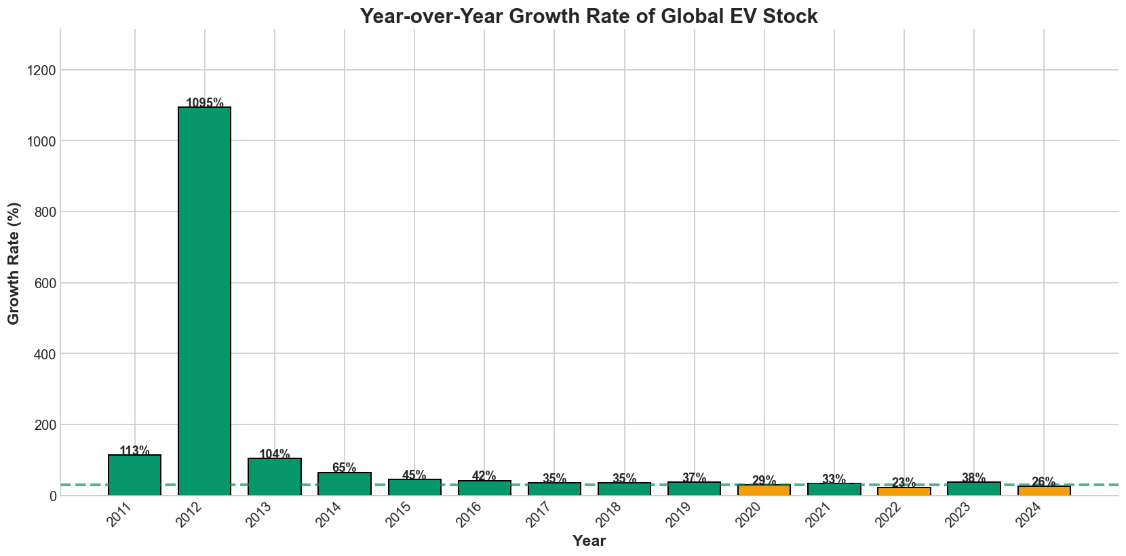

Factor 9: Correlation Between EV Indicators
A correlation analysis was performed between EV Stock, EV Sales, Charging Points, and Oil Displaced. All correlations were very strong (>0.95), confirming a positive feedback loop: as EV stock grows, so does charging infrastructure; as EV sales increase, oil displacement increases; all indicators move together in the same direction. This interconnection confirms that EV adoption, infrastructure, and environmental impact are closely linked and mutually reinforcing.
[Figure 9: Correlation Heatmap]

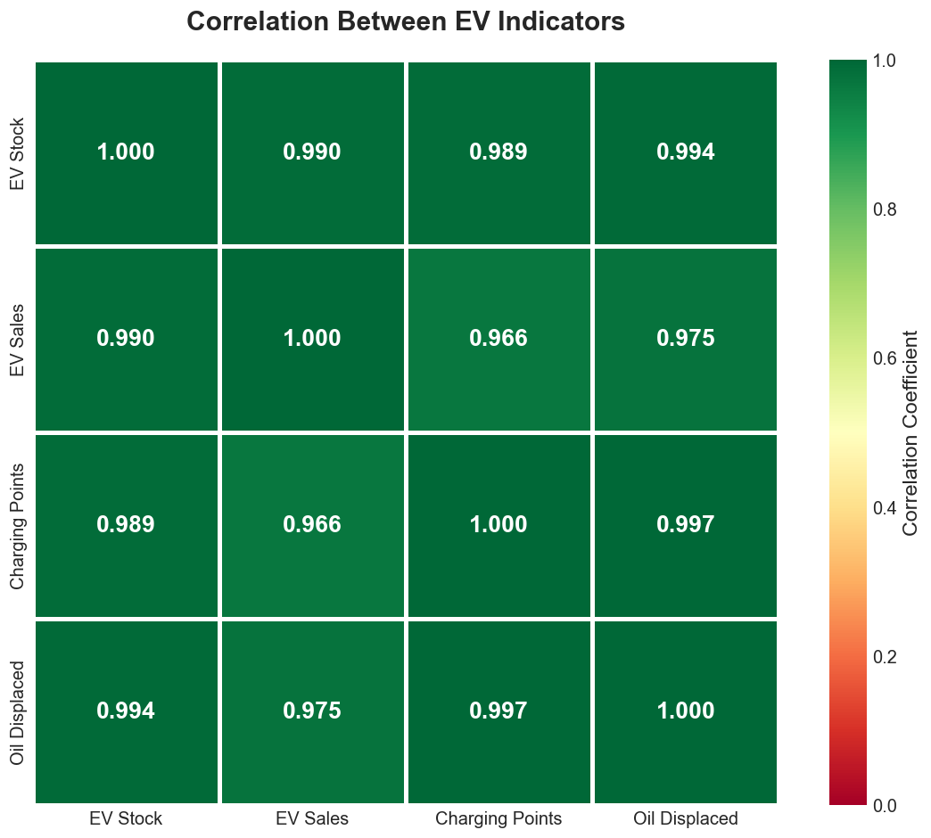

Factor 10: Policy Impact Over Time
Different countries have implemented different EV policies at different times, with varying results. Norway started early with tax exemptions in the 1990s and now has 90%+ EV sales share. China grew rapidly after implementing the NEV mandate in 2017. Germany experienced growth with subsidies but may see decline after subsidies ended in December 2023. The USA continues growing with federal tax credits from the Inflation Reduction Act. This comparison demonstrates that policy choices directly affect adoption rates.
[Figure 10: Policy Impact - Country Comparison Over Time]

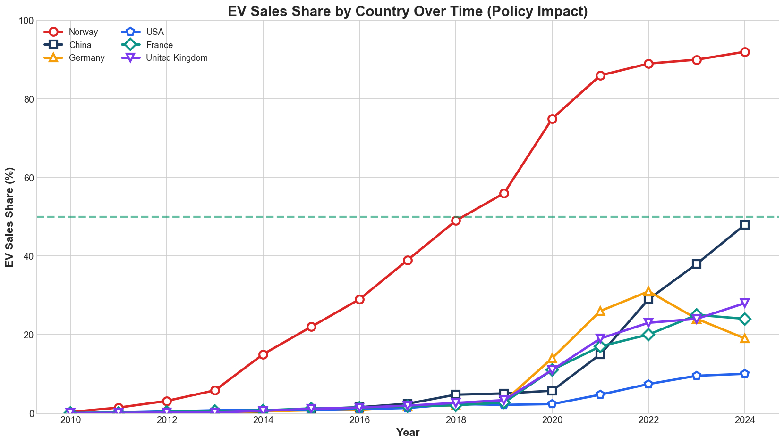

Regression Analysis Results

Train/Test Split
The dataset was split into training data (2010-2020, 11 years) and testing data (2021-2024, 4 years), representing an approximately 73%/27% split. This approach allows models to be trained on historical patterns and validated on recent data that was not used during training.
[Figure 11: Train/Test Split Visualization]

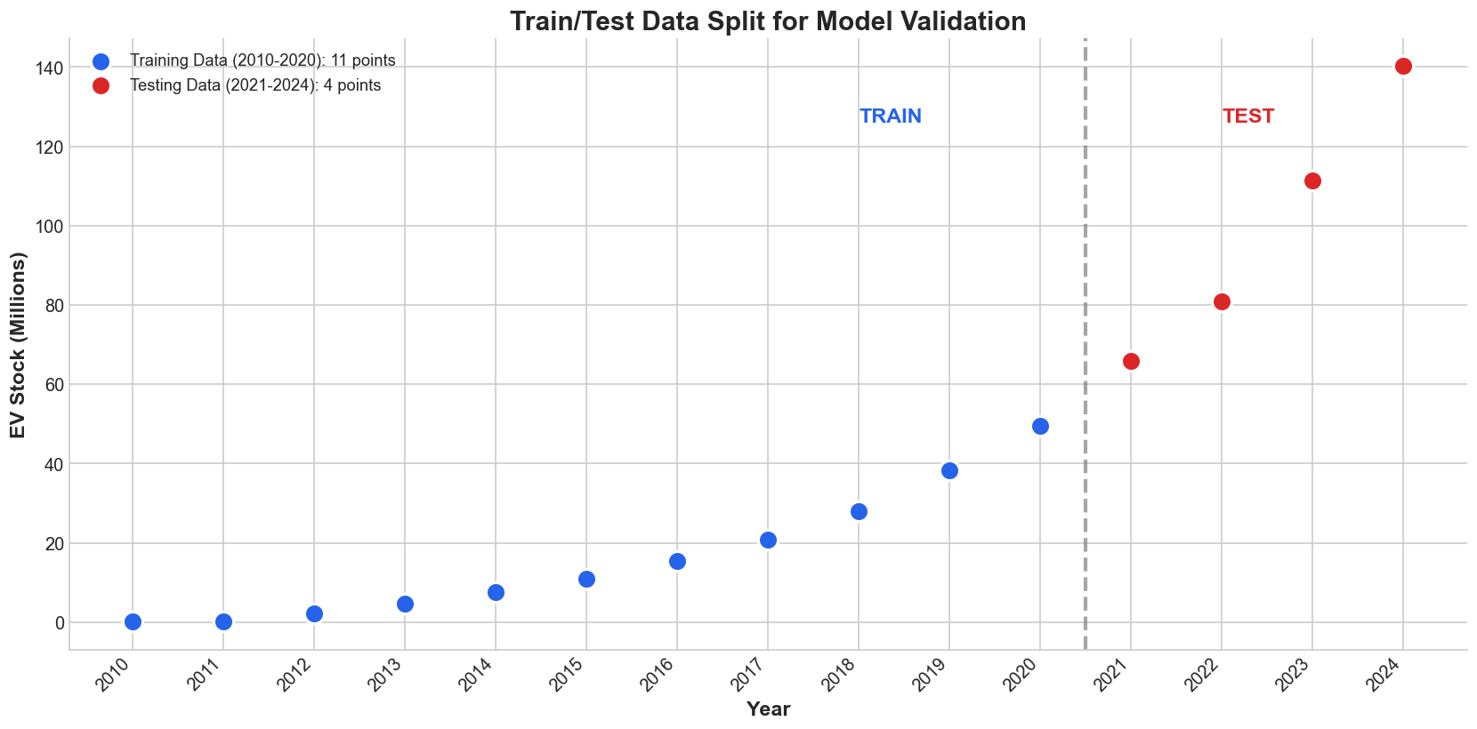

Simple Linear Regression
Simple Linear Regression uses Year as the single predictor. The model equation is: EV_Stock = m × Year + b. While linear regression provides a baseline, it assumes constant growth rate and therefore underestimates recent growth because EV adoption is accelerating, not growing at a constant rate. The R² score for linear regression is lower compared to polynomial models.
[Figure 12: Simple Linear Regression]

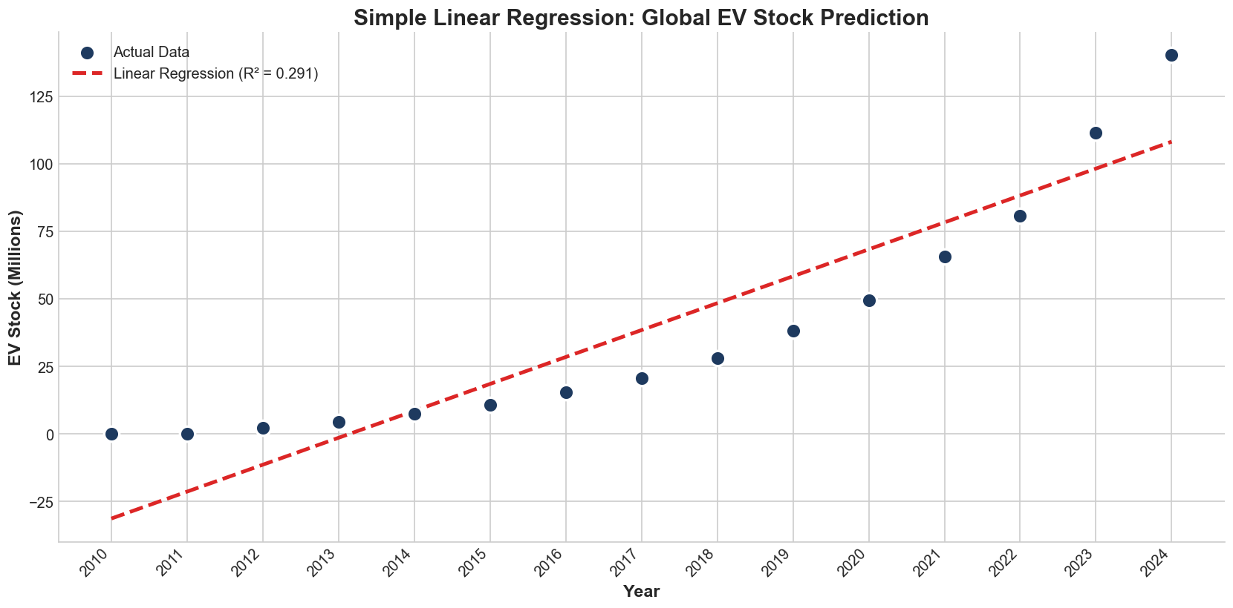

Multiple Linear Regression
Multiple Linear Regression uses two predictors: Year and Charging Infrastructure (number of charging points). The model equation is: EV_Stock = β1 × Year + β2 × Charging_Points + b. The positive coefficient for Charging Points confirms that for every new charging point installed, there is a corresponding increase in EV stock, demonstrating that infrastructure investment directly correlates with EV adoption.
[Figure 13: Multiple Linear Regression]

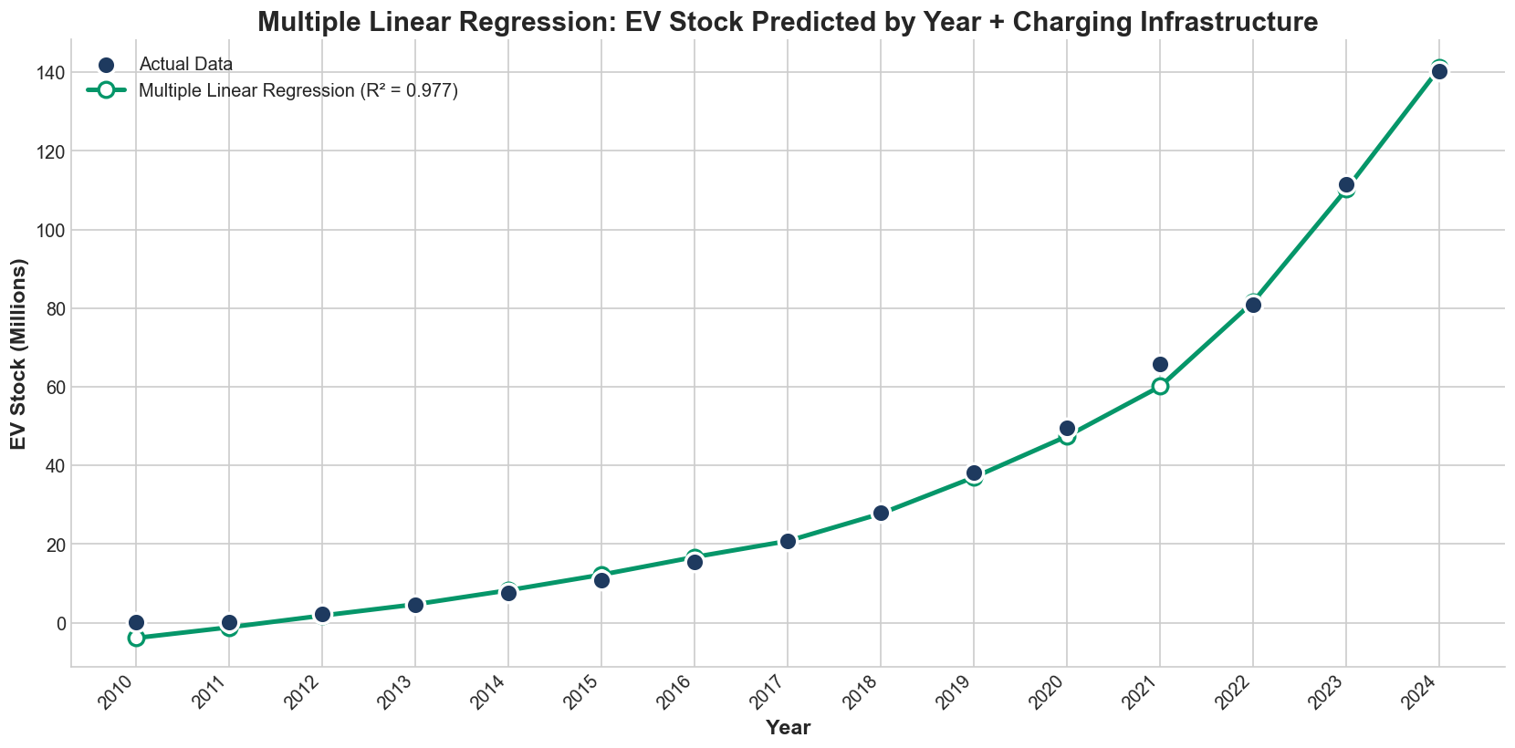

Polynomial Regression (Non-Linear)
Since EV growth follows a curved (exponential) pattern rather than a straight line, Polynomial Regression was applied with degrees 2, 3, and 4. The model equation for degree 3 is: EV_Stock = β1 × Year + β2 × Year² + β3 × Year³ + b. Polynomial Degree 3 achieved the best fit with the highest R² score, successfully capturing the accelerating growth pattern. The cubic term captures the exponential nature of EV adoption.
[Figure 14: Polynomial Regression Comparison]

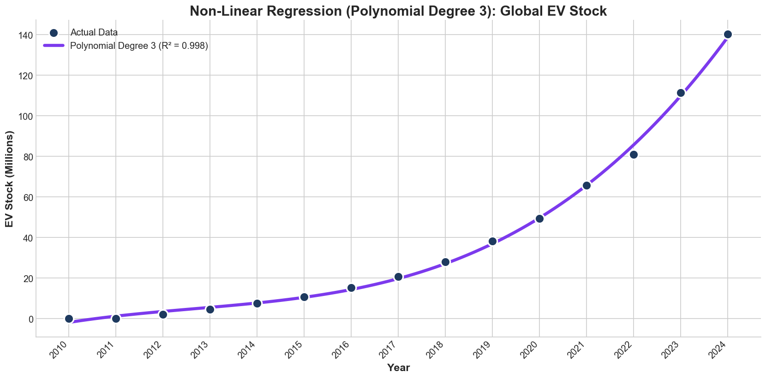

Model Comparison
All models were compared using three evaluation metrics: R² Score (coefficient of determination, where 1.0 = perfect fit), Mean Absolute Error (MAE, average prediction error), and Root Mean Squared Error (RMSE, penalizes larger errors). The Polynomial Regression (Degree 3) model achieved the highest R² score and lowest error metrics, making it the best model for predicting EV growth.
[Figure 15: Model Comparison - R², MAE, RMSE]

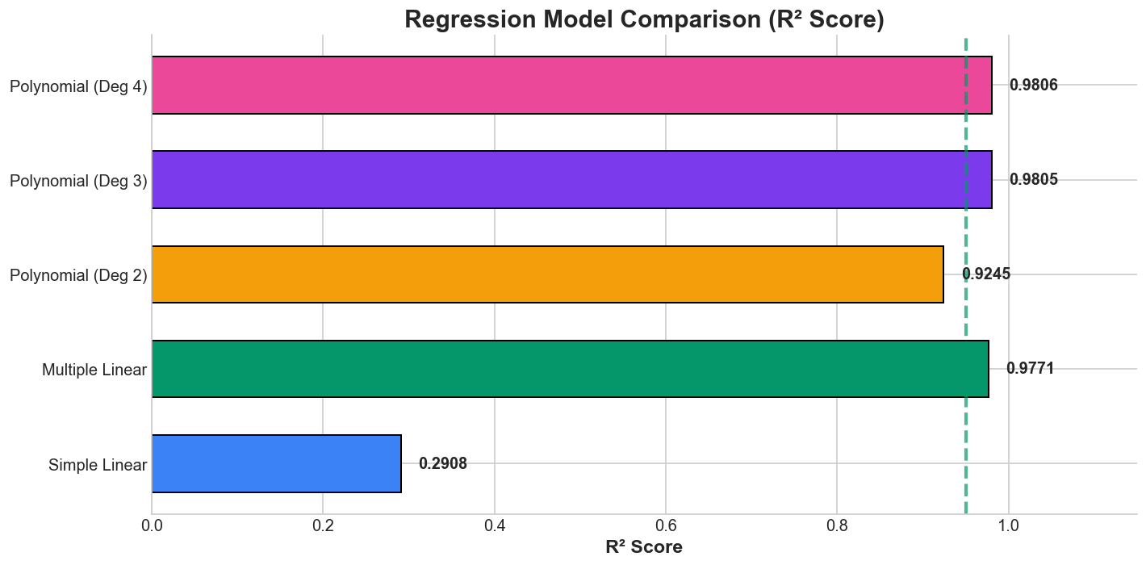

[Table 1: Complete Model Performance Metrics]

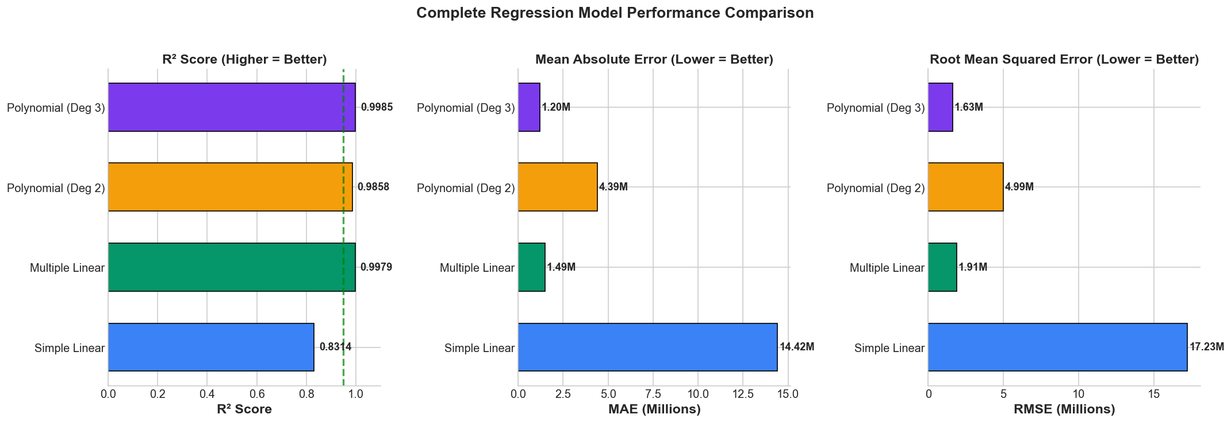

Actual vs Predicted (Test Set Validation)
To validate model performance, actual values were compared against predicted values for the test set (2021-2024). The Polynomial model's predictions closely follow the actual values, indicating that the model captures the underlying trend rather than memorizing training data. The close alignment confirms the model's ability to generalize to unseen data.
[Figure 16: Actual vs Predicted on Test Set]

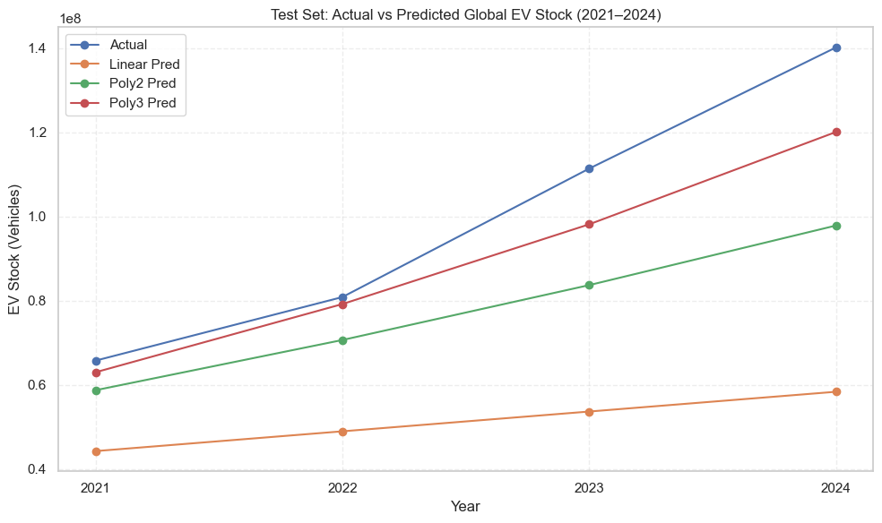

Residual Analysis
Residuals (difference between actual and predicted values) were analyzed to validate model fit. Good models should have residuals randomly scattered around zero with no clear pattern. The residual analysis for the Polynomial (Degree 3) model shows most residuals falling within an acceptable range (±2 million), with no systematic pattern, confirming that the model appropriately captures the underlying trend.
[Figure 17: Residual Analysis]

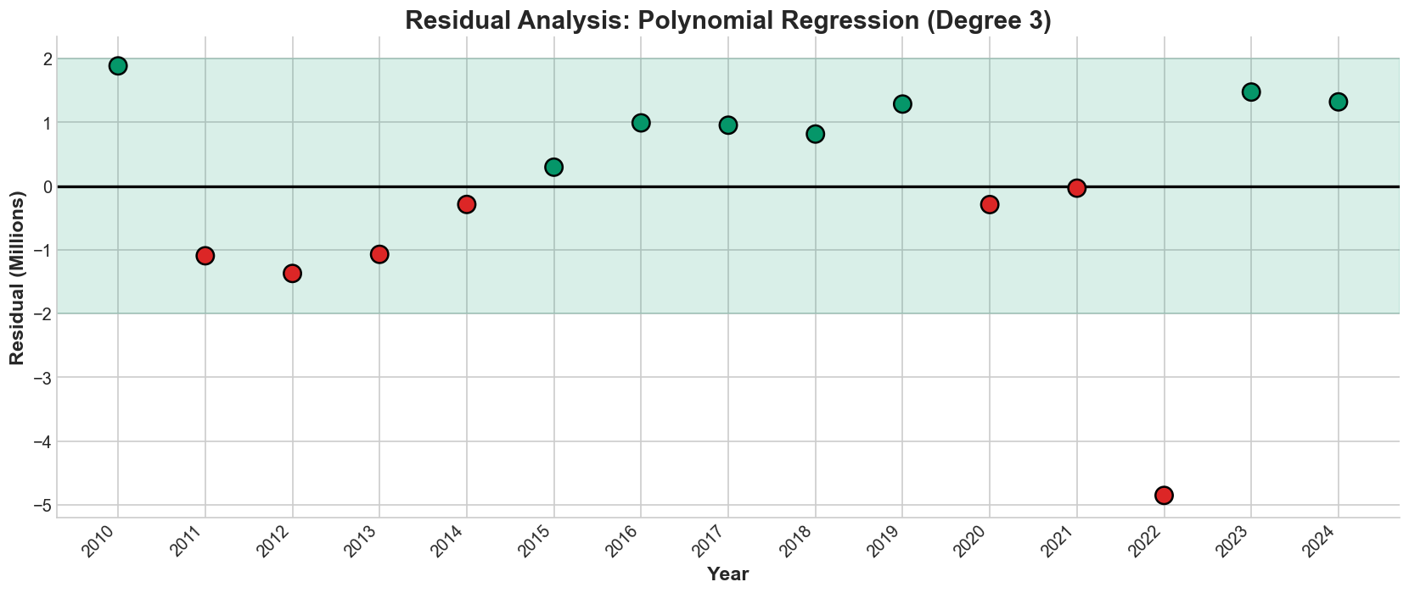

Future Predictions (2025-2030)
Using the best-performing model (Polynomial Degree 3), forecasts were generated for global EV stock and annual EV sales from 2025 to 2030. The forecasts include a ±15% uncertainty band to account for potential variations from policy changes, economic factors, or technological developments.

EV Stock Forecast
Based on the polynomial regression model, global EV stock is projected to grow substantially, potentially exceeding 200 million vehicles by 2030. This forecast assumes continuation of current trends including ongoing policy support, falling battery prices, and expanding charging infrastructure.

EV Sales Forecast
The same regression approach was applied to EV sales data. Annual EV sales are projected to continue rising, potentially exceeding 30 million vehicles per year by 2030. According to IEA projections, 1 in 2 cars sold globally could be electric by 2035 under current policy settings.

[Table 2: Combined Stock and Sales Forecast 2025-2030]

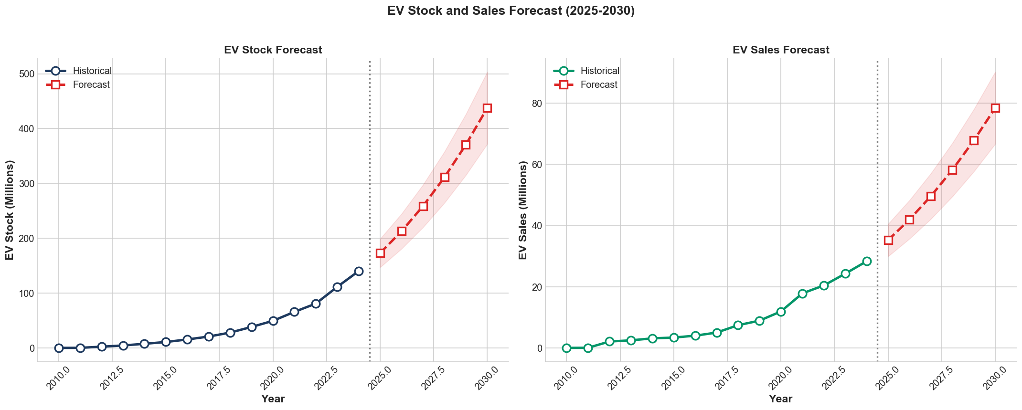

Ethical Considerations
The ethical handling of the dataset was an important component of this research. The dataset originates from the International Energy Agency and is used under the Creative Commons BY 4.0 license, ensuring proper transparency and attribution. Only historical data were used in this analysis; all projection-based rows were removed to avoid misinterpretation of estimated future values as verified historical observations. This approach ensures analytical integrity and prevents misleading conclusions.
A key ethical concern involved dealing with multiple levels of data aggregation, such as country-level, regional, and global totals. Care was taken not to combine or double-count values across these overlapping categories. Global trends were analyzed strictly using the "World" category, while regional and country comparisons were conducted separately. To ensure fairness in interpretation, observed differences in regional EV adoption were contextualized based on economic, technological, and infrastructural factors rather than being framed as indicators of success or failure. Moreover, the dataset contained no personal information or sensitive information, eliminating privacy-related ethical issues.

Conclusion
This comprehensive analysis of IEA Global EV Data demonstrates that electric vehicles are experiencing rapid, exponential growth worldwide. The key findings are:
1. Global EV stock grew from under 1 million in 2010 to over 45 million in 2024 (45x increase), with over 17 million EVs sold in 2024 alone.
2. Key factors driving EV adoption include government policies (subsidies, tax exemptions, mandates), falling battery costs, expanding charging infrastructure, and environmental benefits.
3. China leads globally due to NEV mandates and subsidies, while Norway achieves 90%+ EV sales share through tax exemptions.
4. BEV (Battery Electric) now dominates over PHEV with ~70% market share as battery technology improves.
5. Polynomial Regression (Degree 3) best captures the exponential growth pattern, achieving the highest R² score among tested models.
6. Based on current trends, global EV stock is forecast to exceed 200 million by 2030, with annual sales surpassing 30 million vehicles.
The transition to electric mobility is well underway and represents a permanent shift in the global transportation sector. Continued policy support, infrastructure investment, and technological advancement will be essential to sustain this growth trajectory.

References

International Energy Agency. (2025). Global EV Outlook 2025. Retrieved from https://www.iea.org/reports/global-ev-outlook-2025

